# Introduction

This document describes the different steps and thought when performing the P5 project.

*For the second submission, added text is in Italic. Removed text has been strike though.*

You can customize the way the poi_id.py script behave by settings some Boolean variables.

* showunivariate: will display histogram chart for all features if set to True
* showheatmap: will display the correlation heatmap if set to True
* *showboxplot: will display the correlation bloxplot if set to True*
* showcorrelation: will display correlation scatter plot between features if set to True
* performalltunings: will perform the algorithm tuning is set to True

By default, all these parameters are set to True.

# Descriptive statistics, outliers mgt, features selection

We use all features and retrieve associated descriptive statistics

salary

count 95.000000

mean 562194.294737

std 2716369.154553

min 477.000000

25% 211816.000000

50% 259996.000000

75% 312117.000000

max 26704229.000000

If I look to the maximum value of salary, I see it corresponds to the total value of salaries from the enron61702insiderpay.pdf. I will delete the TOTAL values and re-compute descriptive statistics.

salary bonus long_term_incentive deferred_income \

count 94.000000 81.000000 65.000000 48.000000

mean 284087.542553 1201773.074074 746491.200000 -581049.812500

std 177131.115377 1441679.438330 862917.421568 942076.402972

min 477.000000 70000.000000 69223.000000 -3504386.000000

25% 211802.000000 425000.000000 275000.000000 -611209.250000

50% 258741.000000 750000.000000 422158.000000 -151927.000000

75% 308606.500000 1200000.000000 831809.000000 -37926.000000

max 1111258.000000 8000000.000000 5145434.000000 -833.000000

deferral_payments loan_advances other expenses \

count 38.000000 3.000000 92.000000 94.000000

mean 841602.526316 27975000.000000 465276.663043 54192.010638

std 1289322.626180 46382560.030684 1389719.064851 46108.377454

min -102500.000000 400000.000000 2.000000 148.000000

25% 79644.500000 1200000.000000 1209.000000 22479.000000

50% 221063.500000 2000000.000000 51984.500000 46547.500000

75% 867211.250000 41762500.000000 357577.250000 78408.500000

max 6426990.000000 81525000.000000 10359729.000000 228763.000000

director_fees total_payments exercised_stock_options \

count 16.000000 1.240000e+02 101.000000

mean 89822.875000 2.623421e+06 2959559.257426

std 41112.700735 9.488106e+06 5499449.598994

min 3285.000000 1.480000e+02 3285.000000

25% 83674.500000 3.863802e+05 506765.000000

50% 106164.500000 1.100246e+06 1297049.000000

75% 112815.000000 2.084663e+06 2542813.000000

max 137864.000000 1.035598e+08 34348384.000000

restricted_stock restricted_stock_deferred total_stock_value \

count 109.000000 17.000000 125.000000

mean 1147424.091743 621892.823529 3352073.024000

std 2249770.356903 3845528.349509 6532883.097201

min -2604490.000000 -1787380.000000 -44093.000000

25% 252055.000000 -329825.000000 494136.000000

50% 441096.000000 -140264.000000 1095040.000000

75% 985032.000000 -72419.000000 2606763.000000

max 14761694.000000 15456290.000000 49110078.000000

to_messages from_poi_to_this_person from_messages \

count 86.000000 86.000000 86.000000

mean 2073.860465 64.895349 608.790698

std 2582.700981 86.979244 1841.033949

min 57.000000 0.000000 12.000000

25% 541.250000 10.000000 22.750000

50% 1211.000000 35.000000 41.000000

75% 2634.750000 72.250000 145.500000

max 15149.000000 528.000000 14368.000000

from_this_person_to_poi shared_receipt_with_poi poi

count 86.000000 86.000000 145.000000

mean 41.232558 1176.465116 0.124138

std 100.073111 1178.317641 0.330882

min 0.000000 2.000000 0.000000

25% 1.000000 249.750000 0.000000

50% 8.000000 740.500000 0.000000

75% 24.750000 1888.250000 0.000000

max 609.000000 5521.000000 1.000000

I can see that:

* There are 145 peoples in the dataset (there are 18 POIs within this set of 145 peoples).
* Only the POI feature has been fully set (all other feature have missing values)
* Emails data is filled for only 86 peoples.
* The deferral_payments, restricted_stock, restricted_stock_deferred , total_stock_value have positive values and negative values in it.
* There are a very small number of information for features loan_advances, director_fees and restricted_stock_deferred.

As a consequence, I decide to:

* Remove features loan_advances, director_fees and restricted_stock_deferred from the dataset and analysis.
* Delete negative values for features: deferral_payments, restricted_stock, total_stock_value

I decide then to have a look on data distribution using a histogram chart.

I see that a lot of feature distributions are skewed: bonus, long_term_incentive, deferred_income, deferral_payments, other, expenses, total_payments, exercised_stock_options, restricted_stock, total_stock_value, to_messages, from_poi_to_this_person, from_messages, from_this_person_to_poi, shared_receipt_with_poi.

In the machine learning algorithm, I will check if applying a log transformation on these feature values helps.

I can also find some outliers values, but I decide to keep these values as they are real values.

I now want to have a look on possible correlated data in my dataset.

We can find some strong correlations, for instance between deferral_payments and deferred_income, total_stock_value and restricted_stock, to_message and from_this_person_to_poi, to_message and shared_receipt_with_poi.

On the other hand, I notice there is not strong between poi and all other variables.

When looking to the variables scatter plots, I decided not to perform any data transformation based on these correlations. I prefer to rely on the principal component algorithm with prior Min/Max scaling.

When looking to the correlation matrix, we identify 3 groups of data:

* Salary related information
* Stock related information
* Email related information.

When doing the machine learning algorithm tweak, I will evaluate performance using:

* All selected features
* Only the total_payments, total_stock_value and all emails features.

Missing values will be replaced with 0. I think that other standard strategies (Mean, Median, Most frequent) proposed in sklearn are not relevant in our case.

# Additional features creation

We can reasonably think that email exchange between POIs may be greater than between POIs and non POIs.

Instead of working with absolute values, I decide to create two additional ratios:

* poi_to_ratio = from_poi_to_this_person / to_messages
* poi_from_ratio = from_this_person_to_poi / from_messages

~~If we look to correlation, I cannot see a real correlation between POIs and these 2 new ratios.~~

~~poi_to_ratio poi_from_ratio poi~~

~~poi_to_ratio 1.000000 0.245350 0.059688~~

~~poi_from_ratio 0.245350 1.000000 0.312483~~

~~poi 0.059688 0.312483 1.000000~~

*The two-following chart shows the distribution of the two created ratio per poi value.*

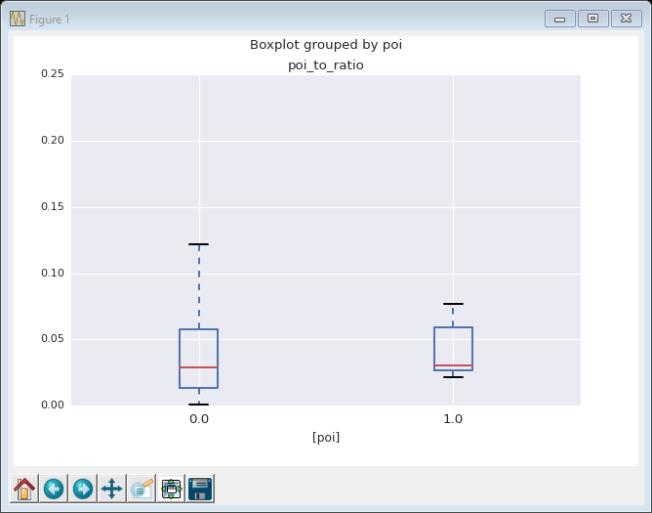

*I can see that the values range for poi and non-poi are not exclusive. This ratio shall not provide additional information to solve our problem.*

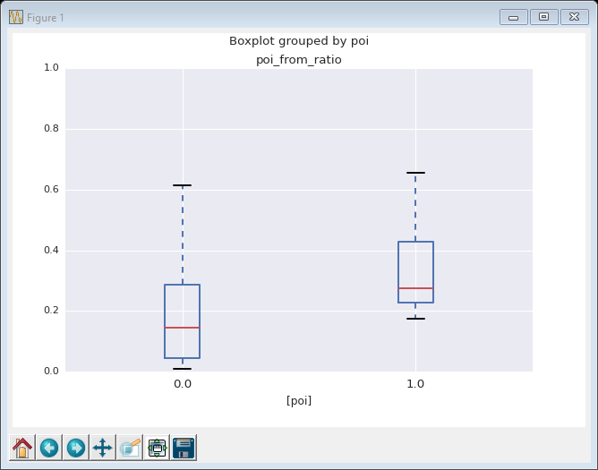

*Even if for POI, the poi_from_ratio is a little bit greater, this new figures does not provide much additional information.*

*The final algorithm selection test will be performed on the standard dataset but also on the standard dataset with these two-additional ratios. Analysis of the machine learning with and without these ratios will be described.*

*Please, see my question about your comment at the end of this document.*

# Machine learning algorithm selection and tuning

*What is parameter tuning and importance of this activity:*

*Each machine learning algorithm have 0 or several parameters. When a machine learning algorithm has on or several parameters, the combination of these parameters values have a significant impact on the capacity of the algorithm to answer our problem. This is the reason why we need to find the best set of parameters values. This is activity is known as parameter tuning. Without this activity, we have a high probability to have a very poor machine learning algorithm.*

I will perform a benchmarking analysis using:

* 3 differents supervised classification machine learning algorithm (Naïve Bayes, Support Vector Machine, Decision Tree).
* Each algorithm will be preceded by a scaling activity (Min/Max) and a principal component anlaysis.
* 3 differents datasets: all features except new ratios, all features including ratios, restricted features excluding ratio. Each time, we will evaluate the algorithm with unchanged information and log changed information.
* 2 differents validation strategies: use of a basic sample of the data set, use of a KFold sets of the data set.
* For SVM algorithm and decision tree algorithms, a random selection based tuning will be used to limit computer CPU usage.

For the PCA algorithm, the number of final component is part of the tuning activity.

For the SVM algorithm, the kernel, C and gamma parameters are part of the tuning activity. The possible values will be:

* C=[1,10,100,1000],
* gamma=[0.01,0.001, 0.0001],
* kernel=['rbf','linear','poly']

For the decision tree algorithm, the criterion and max features parameters are part of the tuning activity. The possible values will be:

* criterion=['gini','entropy'],
* max_features=['sqrt','log2',None])

*Algorithm validation and importance of this phase:*

*The validation phase consists of using a test dataset in order to evaluate the different performances of our machine learning algorithm. In order to avoid any bias, the test dataset has to be different from the learning dataset. This validation phase is important in order to know the performances of our machine learning algorithm, and to detect any possible misbehavior due to overfitting for instance.*

For each of this test, we will use the f1 scoring function as value to be optimized. This metrics offer a good balance between precision and recall. We will have a look to precision and recall metrics for the selected algorithm.

We use two f1 computation. The one based on estimator.best_score_ value (directly provided by sklearn), and a second computed using a modified version of the test_classifier function from the tester.py.

The results are provided in the following table:

|  |  |  |  |  |  |
| --- | --- | --- | --- | --- | --- |
| Data set | Log values | Val strategy | Algo | F1 (computed) | F1 (best_score_) |
| Full | Yes | Basic | Naïve Bayes | 0.31 | 0.39 |
| Full | Yes | Basic | SVM | 0.03 | 0.61 |
| Full | Yes | Basic | Decision tree | 0.27 | 0.61 |
| Full | Yes | KFold | Naïve Bayes | 0.43 | 0.47 |
| Full | Yes | KFold | SVM | 0.19 | 0.42 |
| Full | Yes | KFold | Decision tree | 0.28 | 0.38 |
| Full | No | Basic | Naïve Bayes | 0.19 | 0.46 |
| Full | No | Basic | SVM | 0.20 | 0.60 |
| Full | No | Basic | Decision tree | 0.28 | 0.52 |
| Full | No | KFold | Naïve Bayes | 0.43 | 0.47 |
| Full | No | KFold | SVM | 0.20 | 0.42 |
| Full | No | KFold | Decision tree | 0.29 | 0.32 |
| Full with ratio | Yes | Basic | Naïve Bayes | 0.27 | 0.39 |
| Full with ratio | Yes | Basic | SVM | 0.02 | 0.62 |
| Full with ratio | Yes | Basic | Decision tree | 0.28 | 0.46 |
| Full with ratio | Yes | KFold | Naïve Bayes | 0.27 | 0.4 |
| Full with ratio | Yes | KFold | SVM | 0.02 | 0.47 |
| Full with ratio | Yes | KFold | Decision tree | 0.28 | 0.48 |
| Full with ratio | No | Basic | Naïve Bayes | 0.27 | 0.39 |
| Full with ratio | No | Basic | SVM | 0.02 | 0.62 |
| Full with ratio | No | Basic | Decision tree | 0.28 | 0.42 |
| Full with ratio | No | KFold | Naïve Bayes | 0.27 | 0.4 |
| Full with ratio | No | KFold | SVM | 0.02 | 0.47 |
| Full with ratio | No | KFold | Decision tree | 0.28 | 0.5 |
| Limited | Yes | Basic | Naïve Bayes | 0.37 | 0.35 |
| Limited | Yes | Basic | SVM | 0 | 0 |
| Limited | Yes | Basic | Decision tree | 0.22 | 0.28 |
| Limited | Yes | KFold | Naïve Bayes | 0.35 | 0.32 |
| Limited | Yes | KFold | SVM | 0 | 0 |
| Limited | Yes | KFold | Decision tree | 0.22 | 0.26 |
| Limited | No | Basic | Naïve Bayes | 0.38 | 0.35 |
| Limited | No | Basic | SVM | 0 | 0 |
| Limited | No | Basic | Decision tree | 0.22 | 0.28 |
| Limited | No | KFold | Naïve Bayes | 0.35 | 0.32 |
| Limited | No | KFold | SVM | 0 | 0 |
| Limited | No | KFold | Decision tree | 0.21 | 0.22 |

**Interpretation**

**Validation strategy**

We see that when tuned, the SVM algorithm including all features (+ additional ratios) is the better performance using a basic validation strategy.

|  |  |  |  |  |  |
| --- | --- | --- | --- | --- | --- |
| Data set | Log values | Val strategy | Algo | F1 (computed) | F1 (best_score_) |
| Full with ratio | Yes | Basic | SVM | 0.02 | 0.62 |
| Full with ratio | No | Basic | SVM | 0.02 | 0.62 |

But we see that when applying the Udacity validation strategy, this algorithm behave badly.

This is clearly important to perform validation in the way the algorithm will be used in operation condition.

At the end, the best algorithm is not the one providing the best tuned result.

|  |  |  |  |  |  |
| --- | --- | --- | --- | --- | --- |
| Data set | Log values | Val strategy | Algo | F1 (computed) | F1 (best_score_) |
| Full | Yes | KFold | Naïve Bayes | 0.43 | 0.47 |
| Full | No | KFold | Naïve Bayes | 0.43 | 0.47 |

The final selected algorithm is a pipeline of:

* Min Max scaler
* PCA with 12 components
* Naïve Bayes classifier

*The following chart shows the explained variance for the 12 components:*

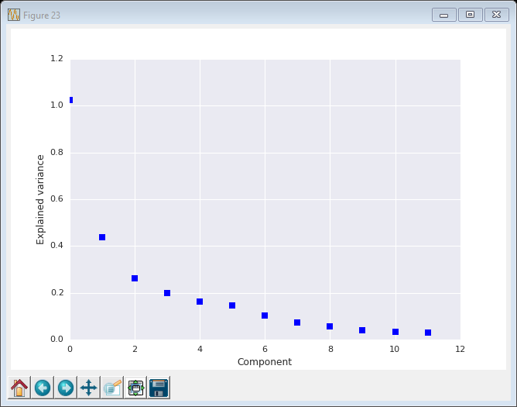

Output from the tester.py script are:

Accuracy: 0.83440 Precision: 0.39702 Recall: 0.46650 F1: 0.42897 F2: 0.45072

Total predictions: 15000

True positives: 933 False positives: 1417 False negatives: 1067 True negatives: 11583

POIs were identified in 47% of the cases, and when identified, we were right in 40% of cases.

http://www.h5.com/document-review-accuracy-the-recall-precision-tradeoff/

Globally, I consider this algorithm a bit weak.

When we run a simple test strategy, we can find results looking like the following one:

precision recall f1-score support

0.0 0.89 1.00 0.94 39

1.0 0.00 0.00 0.00 5

avg / total 0.79 0.89 0.83 44

The algorithm behave pretty good, but it is very efficient identifying non POIs. He is totally week for detecting POIs.

This may come from our initial dataset with a lot of missing values.

As a conclusion, I see that the algorithm validation phase is crucial and has to be well thought.

**Log transformation of feature**

|  |  |  |
| --- | --- | --- |
| **Row Labels** | **Average of F1 (computed)** | **Average of F1 (best_score_)** |
| No | 0.216111111 | 0.375555556 |
| Yes | 0.211666667 | 0.383888889 |
| **Grand Total** | **0.213888889** | **0.379722222** |

We see that the log transformation of features values has no real impact on the algorithm performances.

**Inclusion of new features**

|  |  |  |
| --- | --- | --- |
| **Row Labels** | **Average of F1 (computed)** | **Average of F1 (best_score_)** |
| Full | 0.258333333 | 0.4725 |
| Full with ratio | 0.19 | 0.468333333 |
| Limited | 0.193333333 | 0.198333333 |
| **Grand Total** | **0.213888889** | **0.379722222** |

We see that inclusion of the two new ratios does not provide a significant impact on the performances of the algorithm. It even tends to decrease it performance.

I applied the PCA algorithm prior to the final machine learning algorithm tuning. If the new ratios do not add new information, they will not be considered (or weakly considered) by PCA algorithm.

*Feedback about 1st review:*

**At least one new feature is implemented. Justification for that feature is provided in the written response, and the effect of that feature on the final algorithm performance is tested. The student is not required to include their new feature in their final feature set.**

Good work engineering your features, including your reasons and testing their impact over your classifier, however correlation is not an appropriate test to determine their importance since POI is a categorical variable, you can find more info [here](http://stats.stackexchange.com/questions/119835/correlation-between-a-nominal-iv-and-a-continuous-dv-variable) on this topic . An appropriate analysis to estimate the relevance of these features would be to calculate the proportions of each value of the independent variable (POI) vs all the values of the dependent variable and then use a test that takes into account these proportions. A [Contingency Table](http://www.eumetcal.org/resources/ukmeteocal/verification/www/english/msg/ver_categ_forec/uos1/uos1_ko1.htm) is an excellent tool for this purpose and [Chi Squared Test](http://stattrek.com/chi-square-test/independence.aspx?Tutorial=AP) is the right test to choose since it will test the observed values of each cell against the expected value of each cell in the contingency table and return a test result with a p-value. For your reference, have a look at [this link](http://math.hws.edu/javamath/ryan/ChiSquare.html) where it is explained the Chi-Squared test and Contingency tables.

Another option is to simply test your classifiers with/without these features.

My answer:

I have some difficulties to understand your comment. I understand that correlation computation was not the right way to check for correlation, as POI is a categorical variable.

But, I am not sure the method you propose can be applied to my new features. I think the method you mention can be applied if my new features are categorical also. In my case, I created two ratios with contiguous values.

There is maybe something wrong in my analysis. Can you provide me with more details for me to understand better?